Database Development and Class Registration

Kevin Vang

The University of Arizona Global Campus

CST499: Capstone Computer Software Technology

Charmelia Butler

12/5/2023

The implementation phase of a web application is a critical stage where academic concepts evolve into a functional and dynamic system. This checks the experience of developing a university registration system web application, focusing on the challenges faced, lessons learned, and insights gained during the process. The objective was to construct a complete web application encompassing student registration, course management, and user authentication. This will delve into the details of the implementation process, including the creation of various PHP files for login, registration, course handling, and a dashboard for logged-in users.

A thorough file structure was essential in realizing the project's objectives. The db.php file laid the foundation by ensuring a secure connection to the MySQL database, prioritizing data integrity and confidentiality. The suite of files related to user authentication (login.php, process_login.php, register.php, process_register.php) implemented strong functionalities, validating user credentials and creating secure sessions upon successful login. The dashboard (dashboard.php) was designed to be inviting, presenting a personalized welcome message and relevant placeholder content, with user authentication checks to ensure authorized access. The course management aspect (register.html, process_register.php, courses.php) eased dynamic course registration, allowing students to add courses to their schedule securely.  
 The challenges were diverse, with designing an efficient and secure database schema proving crucial. Directing relationships between tables governing students, courses, and student courses required meticulous attention. Security considerations, including password storage and protection against SQL injection, demanded rigorous strategies such as prepared statements and password hashing. Ensuring a seamless user experience posed challenges, driving the need for clear error messaging, organized layouts, and fluid navigation.

The implementation phase yielded invaluable lessons. Recognizing the significance of prepared statements in fortifying against SQL injection attacks enhanced overall security. The critical role of proper session management for user authentication and authorization became evident. Emphasizing responsive design principles contributed to an aesthetically pleasing and user-friendly interface.

Contemplating future enhancements, the integration of advanced authentication mechanisms, such as two-factor authentication, is under consideration to bolster the system's security. Exploring dynamic course content by fetching real-time data from the database aims to foster easier maintenance and scalability. Proposing the addition of personalized information to the dashboard, including enrolled courses and announcements, seeks to provide users with a richer and more engaging experience.

To conclude this implementation phase of the university system web application, marked a transformative journey. Navigating challenges in database design, security implementation, and user experience design has provided foundational insights. Recognizing the significance of continuous improvement, the project sets the stage for future enhancements that promise to refine functionality and elevate user engagement. This experience underscores the complexities and rewards of developing robust and user-friendly PHP-based web applications, serving as a meaningful introduction to the world of web development.

**PHP**

DB.php

Index.php

Login.php

Process.login.php

Register.php

**Before**

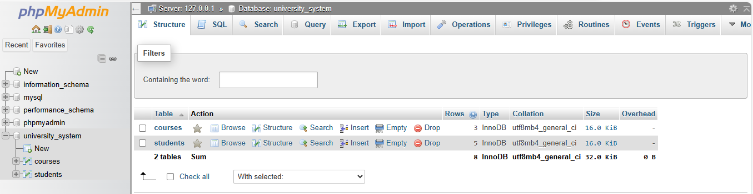

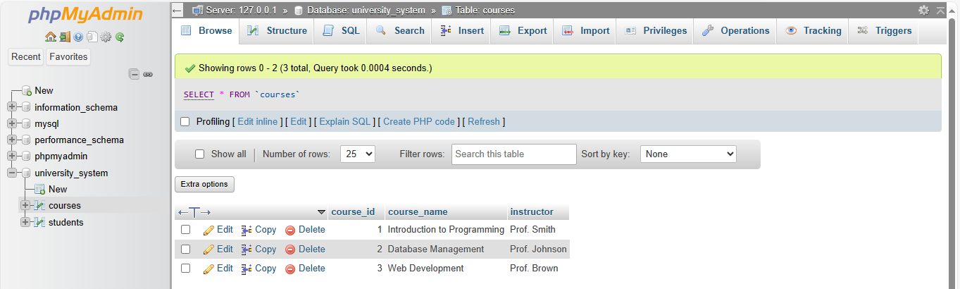

**AFTER**



Entered the login information incorrectly to make sure it is directing it back.  
